**An off grid electrification system**

At the moment we are thinking of having 3 main systems.

1. **Charging system**

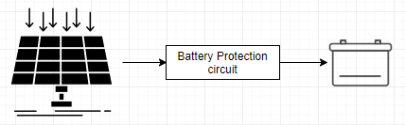

This system constantly measure the voltage on the battery and it will ensure that the battery is protected. Therefore if the battery is full, the charging will stop automatically and if it’s not, the charging will continue.

1. **The power distribution**

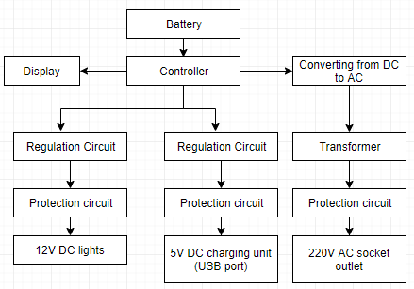

The battery life will be shown on the screen and it will be monitored using a controller. The system will have 3 loads: 12V DC lights, 5V DC charging unit, and 220V AC socket outlet. The power will be distributed to the loads with the following assumptions:

* If the battery life is greater than 30%, all loads will be activated.
* If the battery life is between 20% and 30%, only the lights and USB charging unit will operate.
* If the battery life is between 5% and 20%, only the USB charging unit will operate.
* If the battery life is less than 5%, all loads will be off to prolong the lifespan of the battery.

The lights and the USB charging unit will receive power from their own regulation circuits to ensure that they obtain constant voltage supply, e.g. a boost converter can applied for this application. For the other load we need to have an AC supply, therefore we will have the circuit to convert DC to AC and feed that voltage to a step up transformer because appliances like TV require less power but they are designed to get power from 220V socket outlet. We will have protection circuits for all our power outlets to protect the system.

1. **Dust detection system**

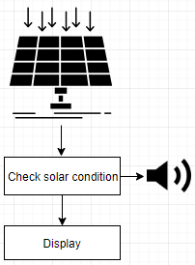

The system will check if the panel is clean and if it is not, there will be a notification on the screen and the alarm will be activated. This will ensure that more energy is harnessed from the sun.